BSc. Artificial Intelligence & Data Science

Level 04

CM 1601

PROGRAMMING FUNDAMENTALS

**T20 Cricket Tournament**

**COURSEWORK-I REPORT**

NADUN SHAMIKA SENARATHNE

IIT ID: 20210488

RGU ID: 2117538

Table of Contents

**FlowChart..........................................................................................................3**

**Source Code ...................................................................................................... 4**

**Visualizing** ............................................................................................................................ 19

**MovingDisks................................................................................................................... 19**

**Test Plan ......................................................................................................... 25**

Test Plan

01)Generating two teams from the two groups randomly and picking one match

* Input :

match_between_A = random.sample(Group_A, 2)

match_between_B = random.sample(Group_B, 2)

chosen_match = [match_between_A,match_between_B]

match_between = random.choice(chosen_match)

print(match_between)

* Expected output:

Ex: Punjab Pakistan vs Kolkata England

* Actual output:

02)Assigning the two picked teams from the match as Home team and Visiting team

* Input :

coin = ["heads", "tails"]

options = ['bat','bowl']

visiting_team = random.choice(match_between)

if visiting_team in match_between:

    match_between.remove(visiting_team)

home_team = match_between[0]

print('Home Team - ', home_team)

print('Visiting Team - ', visiting_team)

* Expected output:

Home team – Delhi New Zealand

Visiting team – Chennai South Africa

* Actual output:

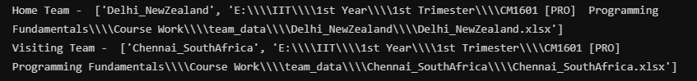

03)Displaying batting card without index column

* Input :

#add batsman_list to score_card_first_ing

score_card_first_ing = batsman_list

# sort score_card_first_ing to the original batting order

sorted_list = sorted(score_card_first_ing, key=itemgetter(5))

# convert score_card_first_ing to a data frame for displaying

df_score_card_first_ing = pd.DataFrame(sorted_list)

df_score_card_first_

* Expected output:

* Actual output:

04)Showing a summary of an innings’ top performers

* Input :

print(team_to_bat[0].replace('_', ' '))

print(df_score_card_first_ing_without_index.nlargest(11, 'Runs'))

print('\n',team_to_bowl[0].replace('_', ' '))

print(df_bowler_list_first_ing_without_index.nlargest(5, 'Wickets'))

print('\nTotal',first_ing_total,'/',first_ing_wickets)

* Expected output:

* Actual output:

